## Memory Compressed Transformer：“Generating wikipedia by summarizing long sequences”

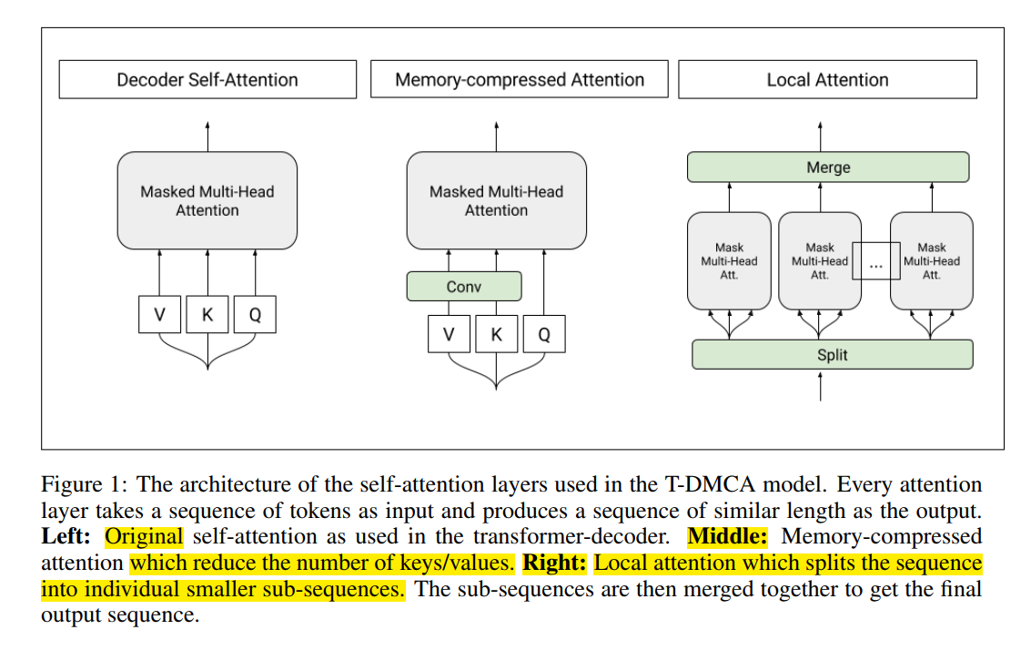

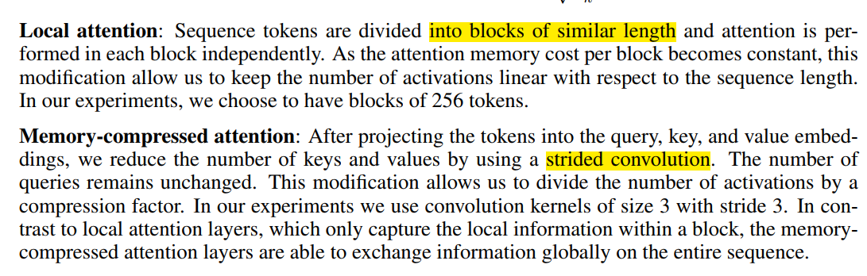

1. Image transformer

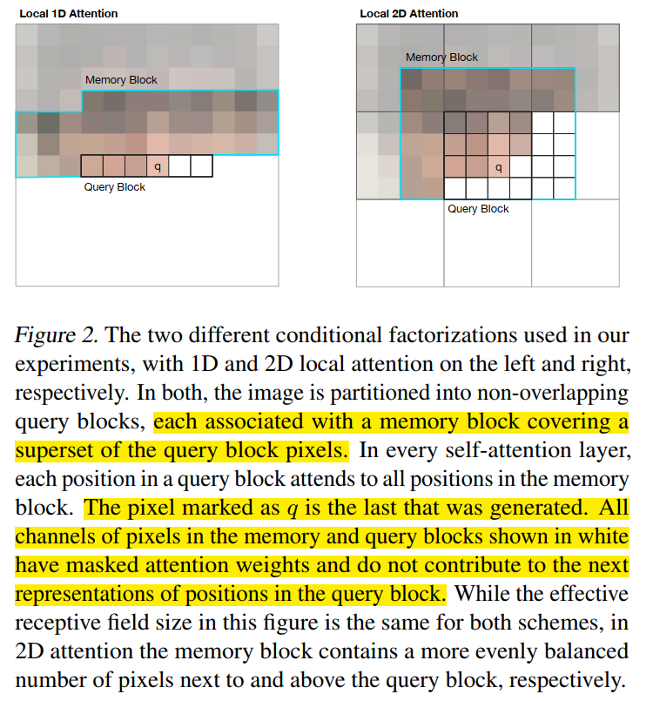

1. Set transformer

A Framework for Attention-based Permutation-Invariant Neural Networks （序列不变）